May 17, 2026
Seventh Sunday of Easter
“All that we are, all that we have,
and all that we will become is a gift from God.”
*Indicates all who can, please stand Bold print invites all to speak or sing!

Gathering Music: “Dialogue” Mozart

* Call to Worship
Come to worship;
to find space, filled,
to find the time, full,
to find the gap, bridged.
Come to worship;
to feel God’s presence here,
know that God has not abandoned us,
but is only a breath away. Come and worship!

*Opening Hymn: “Praise to the Lord, the Almighty” No. 25

* Opening Prayer
In this quiet place, O God we can hear you on the wind calling. In this quiet place, O God, we can feel your presence in us, comforting. In this quiet place, O God, we can sense your grace, holding us. In this quiet place, O God we can meet with you forever, for you are with us always. Amen.

* Prayer of Confession
Blessed One, forgive us for being self-absorbed and choosing to live only for ourselves. Forgive us for ignoring the prompting of your Spirit and placing our will above yours. Give us the courage to be Christ’s witnesses and to carry your loving compassion to a hurting world. Amen.

*Words of Assurance

* Gloria Patri

Please be seated

Choir sings: “I Worship You Almighty God”

Scripture readings: Acts 1: 6-14 John 17: 1-11

Morning Message: “Looking Around”

The United Church Statement of Faith No. 361

Hymn: “Called as Partners in Christ’s Service” No. 453

Sharing our Joys and Concerns
Pastoral Prayer
Lord’s Prayer

Presenting our Gifts

* The Doxology

*The Dedication Prayer
Ever present and loving God, in faith we present these gifts and ourselves to you. Bless and multiply them to meet the needs, both hidden and apparent, of your beloved ones. By the power of the Holy Spirit, we pray. Amen.

*Closing Hymn: “Pass It On” No. 477

* Benediction
We shall go out in hope: the body of Christ alive in the world.
We shall go out in love: the body of Christ alive in the world.
We shall go out in life: the body of Christ alive in the world.
We shall go out in God’s presence: the body of Christ alive in the world.
We shall go out searching: the body of Christ alive in the world.
Amen!

Postlude: “Perpetual Motion” vonWeber

Looking forward:
Next Sunday is Pentecost. It’s the birthday of the Christian Church!
We will celebrate Holy Communion.
Everyone is invited to wear something red as we honor our birthday.

Consistory will meet next Sunday following worship.

Attendance for May 10th was 25 adults.

Happy Heavenly Birthdays-Forest and Betty Neale

Just a reminder: Please silence or turn off your cell phones during worship.
Pastor Diane Thomas
Pastor Phone: (928) 642-6676
Church Phone: (419) 683-2745
Pastor email: dsthomas18@ymail.com
Church email: crestlinecalvary@gmail.com
The church website: www.crestlinecalvary.com
You may view our worship service on YouTube

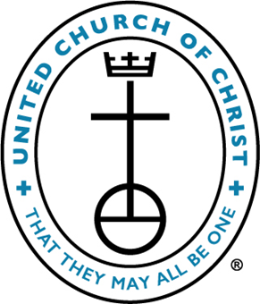

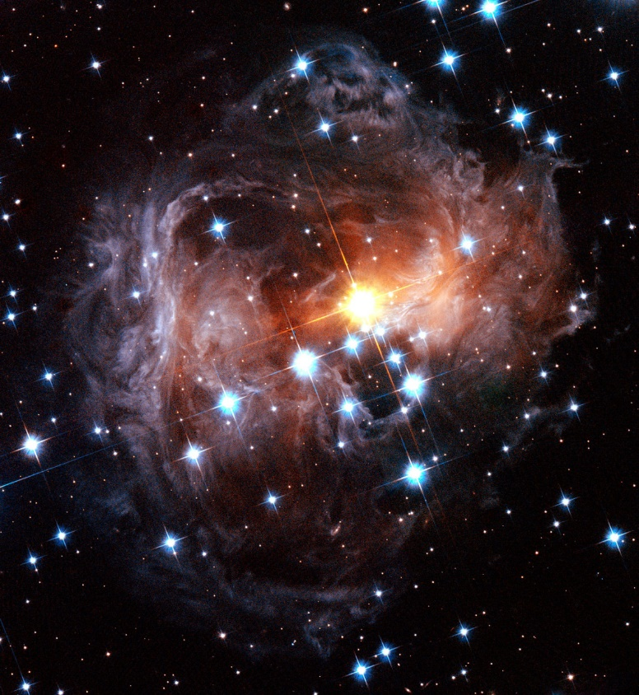
Welcome to Calvary
United Church of Christ
May 17, 2026
Seventh Sunday of Easter
“Serving God and Crestline Since 1859”
We welcome you and thank you for joining in worship!

