May 24, 2026
Pentecost
Communion
“All that we are, all that we have,
and all that we will become is a gift from God.”
*Indicates all who can, please stand Bold print invites all to speak or sing!

Gathering Music: “Ave Maria” Schuber

* Call to Worship
Spirit, Wind, Breath. God
Spirit, Wind, Breath, Love
Spirit, Wind, Breath, Forgiveness
Spirit, Wind, Breath, Hope
Spirit, Wind, Breath
Come, let us worship God in spirit and truth.

*Opening Hymn: “Morning Has Broken” No. 53

* Opening Prayer
God of the heart, God of fire and smoke, with your gifts of the Holy Spirit, may our time of worship and praise challenge us. May we turn the Spirit’s reign in our hearts to fire in our lives. May we glow red with power and love. Amen.

* Prayer of Confession
O God, we confess that we are forever confessing, forever counting on your promise to forgive, but not on the life renewing power of your Spirit. Let that Spirit move among us now; let it burn away all conceit and self-love, all laziness and sloth. Let it move and transform us. Amen.

*Words of Assurance

* Gloria Patri

Please be seated

Choir sings: “God Bless America”

Scripture readings: Acts 2: 1-21

Morning Message: “Happy Birthday Church”

Pentecost Litany: God’s Imagination by Roddy Hamilton
Who puts the copper into beach trees and the waddle into penguins? Who chose the colors of the rainbow and put shapes into clouds?
The Spirit of creation: God’s imagination
Who put notes into music and picked the dance steps for bees?
The Spirit of creation: God’s imagination
Who invented yeast to make bread rise and put the curve into a banana?
Who made laughter infectious and chocolate taste like heaven?
The Spirit of creation: God’s imagination
Today is Pentecost and we celebrate the energy of God who created us and brings us together in a colorful and loving community. We call her the Spirit!

Hymn: “Breathe on Me, Breath of God” No. 254

Sharing our Joys and Concerns
Pastoral Prayer
Lord’s Prayer

Presenting our Gifts

*The Dedication Prayer
With these earthly treasures, we bless the Great God of Red. We sing praises to your name, O Spirit, O Holy Fire of Love and Glory. You who touch the mountains and they smoke, we honor you all the days of our lives, as you have given yourself to make us holy. We are blessed by giving ourselves away to you. Amen.

*Communion Hymn: “One Bread, One Body” No. 393

Invitation to Communion
Words of Institution, Consecration, Sharing the Elements

*Prayer of Thanksgiving
We thank you God, for the gifts you give us; for the bread of our being loved, for the wine of our joy, for our life together as people ready to do the work of love and justice. And now, we pray that, having been refreshed at this table, we may be bread and wine for each other and for the world. Amen.

*Closing Hymn: “Jesus Shall Reign Where’er the Sun” No. 95
* Benediction
As we go from this place,
may the wind of the Spirit startle our senses and blow through our lives.
May the fire of the Spirit,
scorch our complacency and light our way.
And may the Holy One-Creator, Redeemer, Sustainer,
rest with us now and forever. Amen.

Postlude: “Psalm of Glory”

Looking forward:
Consistory will meet this morning following worship.
Attendance for May 17th was 18 adults.

Just a reminder: Please silence or turn off your cell phones during worship.
Pastor Diane Thomas
Pastor Phone: (928) 642-6676
Church Phone: (419) 683-2745
Pastor email: dsthomas18@ymail.com
Church email: crestlinecalvary@gmail.com
The church website: www.crestlinecalvary.com
You may view our worship service on YouTube

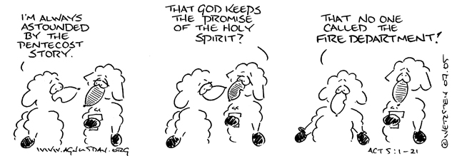

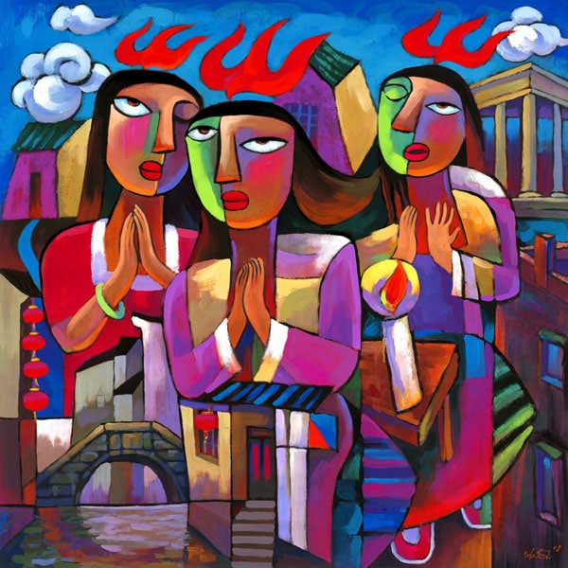

Welcome to Calvary
United Church of Christ
May 24, 2026
Pentecost
Communion
“Serving God and Crestline Since 1859”
We welcome you and thank you for joining in worship!

