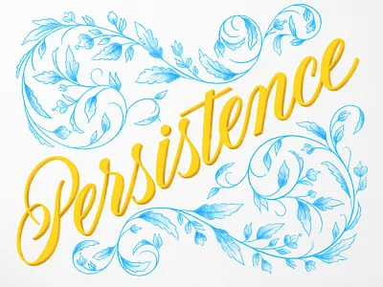
When the world says, “Give up,” Hope whispers, “Try it one more time.” Author unknown
This is a meditation/reflection from Timoty Merrill that I’d like to share with you.
Merrill recounts this story about Niccolo Paganini, a gifted 19th century violinist. In addition to being a great musician, Paganini was also known for his quick sense of humor as well as being a great showman.
It seems that one evening Paganini was performing with a full orchestra in Italy in a packed house. The audience dearly loved him. Toward the end of the concert one string on his violin snapped and hung limply from his violin. Paganini frowned a bit, shook his head and continued to play, improvising beautifully. Then to everyone’s surprise a second string broke and then unbelievable, a third string broke!
Paganini stood there with three strings dangling from his Stradivarius. But instead of leaving the stage, Paganini stood his ground and calmly completed the difficult piece of music on the one remaining string.
Merrill points out that this is a wonderful story, but that Paganini from time to time would intentionally break strings so he could display his virtuosity.
So, what’s the lesson from this story?
Merrill writes, there is no one correct answer, but the story reinforces the importance of perseverance under duress. It could have been easier for Paganini to walk off the stage and get himself another violin, or perhaps cancelling the rest of the concert, but he didn’t.
This is also a lesson in courage since Paganini continued on when in even though it wasn’t at his best.
And it’s also a lesson in humility. Not being able to play at his best, he was willing to play as well as he could with only one string.
Merrill observes it’s important to remember during these somewhat difficult days that God knows how many strings we have. God knows if we have four, three, two or even one. Or it could be that at times we have no strings at all.
Yet God knows and understands. No matter how many strings we have we have been given the gift of God’s music to surround us with love, grace, mercy and compassion. God hears us no matter what sort of music we may be playing these days.
And it’s important for us to keep on playing no matter what.
Come to God with your hesitations, limitations, and brokenness. God hears, God listens and who knows, we may all be playing beautiful music no matter what our circumstances are.
Prayer: God, I am out of strings. I am out of energy. I have nothing left. But what I have, I give to you. Amen.
Blessings and Peace,
Pastor Diane

