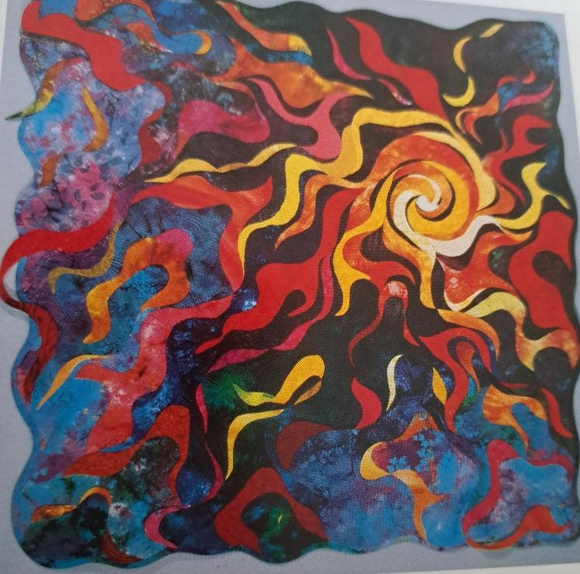
“The Fire Within” a quilt designed and crafted by Vikki Pignatelli
The Apostle Paul in his first letter to the Corinthians said this “Now there are a variety of gifts, but the same Spirit, and there are varieties of services, but the same Lord; To each is given the manifestation of the Spirit for the common good.”
Vikki Pignatelli dedicated this quilt to the Holy Spirit. She reminds us that each one of us glows with the spirit of creativity, just as Paul reminds us that each one of us is uniquely gifted by the Holy Spirit whether we know it or not.
It’s true not all of us can create works of art, or design quilts, but we have been gifted by the Holy Spirit with different sorts of gifts that are to be used for the common good. You see Paul was reminding the congregation in Corinth and us today that whatever gifts we have are to be given freely for the work of Christ.
Vikki writes this: Each one of us glows with the spirit of creativity… very special gifts and talents given to us individually by our Creator. Vikki goes on to say, “The Fire Within” depicts this concept of creativity burning deep within us. Our gifts and talents are the flames that radiate from our inner soul outward through the world, affecting others in ways we aren’t aware of.
This Sunday during worship we will be celebrating Pentecost, that surprising and puzzling day when the Christian Church was born. It took the flames of the Holy Spirit to ignite people and inflame them with the desire to get up and get moving and create what we know as the Christian Church.
So, let’s celebrate the gifts that the Holy Spirit has given us, no matter what they may be. We are a gifted, creative people of God who have so much to share.

This is a prayer written by Vikki.
Heavenly Creator, open my eyes to the beauty around me. Let me rejoice in the simple wonders you have created. Allow me to recognize your presence in the everyday miracles that happen.
You have made me in your image and have blessed me with your special gift of creativity. Help me use my unique gifts, talents and abilities in a way that reflects your love for me. Inspire me to be an instrument for your work here on earth.
Blessings and Peace,
Pastor Diane

