June 7, 2026
Second Sunday after Pentecost
“All that we are, all that we have,
and all that we will become is a gift from God.”
*Indicates all who can, please stand Bold print invites all to speak or sing!

Gathering Music: “”

* Call to Worship
God pours out a cup of welcome for friends and strangers, for our enemies.
Let us drink deeply of God’s living water.
God pours out a cup of comfort for the grieving and for those in despair, for us, for our enemies.
Let us drink deeply of God’s living water.
God pours out a cup of forgiveness for the oppressor and the oppressed, for us, for our enemies.
Let us drink deeply of God’s living water. Come, let us worship!

* Opening Hymn: “Sister, Let Me Be Your Servant” No.490

* Prayer of Invocation
Living God, we enter this time of worship, feeling you calling us and urging us to be part of your family. We stand with all people gathered here in hopeful community, choosing to be a place where your generosity and kindness dwell. Amen.

* Prayer of Confession
God, we come into this place with our imperfections, our failures and limited by our fears. We come grieving our losses and struggling with our incapacities. We come with our conflicts and sadness, we come because we have been wrong and have been wronged against. Abide with us as we seek strength in our weakness and forgiveness for our wrong doings. Amen.

*Words of Assurance

* Gloria Patri

Please be seated

Scripture readings: Genesis 21: 8-21 Matthew 10: 34-42

Morning Message: “Live Boldly”

Hymn: “Great Is Thy Faithfulness” No. 86

Sharing our Joys and Concerns
Pastoral Prayer
Lord’s Prayer

Presenting our Gifts

* The Dedication Prayer
Great and loving God, who hears the cries of your people and who proclaims
each and every one of us to be of great worth: take these gifts we offer. May our
giving help your church to proclaim the gospel of justice and truth throughout
the world. Amen.

Closing Hymn “Where Cross the Crowded Ways of Life” No.665

* Benediction
God welcomed us with a cup of cold water: the refreshing invitation from a friend to “come in”.
God asks us to offer such a cup to others.
God welcomed us with a cup of cold water: a moment of shared tears in a time of grief or loss.
God ask us to offer such a cup to others.
God welcomed us with a cup of cold water: cleansing offer of forgiveness in a time of shame.
God is a hidden spring in the desert rock. God is an ever-flowing stream of righteousness. God is living water. Come, let us offer a cup of water to a thirsty world. Amen.

Postlude:

Just a reminder: Please silence or turn off your cell phones during worship.

Attendance for May 31st was 21 adults and 1 youth.

Pastor Diane Thomas
Pastor Phone: (928) 642-6676
Church Phone: (419) 683-2745
Pastor email: dsthomas18@ymail.com
Church email: crestlinecalvary@gmail.com
The church website: www.crestlinecalvary.com
You may view our worship service on YouTube

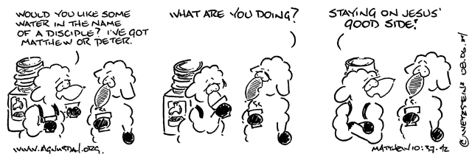


Welcome to Calvary
United Church of Christ
June 7, 2026
Second Sunday after Pentecost
“Serving God and Crestline Since 1859”
We welcome you and thank you for joining in worship!

