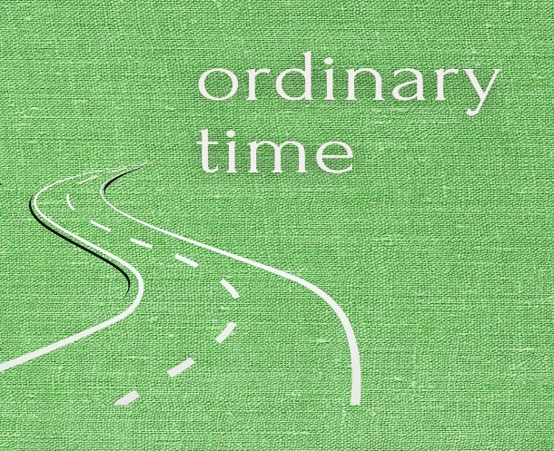
Nothing But Ordinary
It’s Ordinary Time, did you know that? In the life of the Christian Church we have “seasons.” Right now we’re in the Ordinary Season.
This is the longest Season of the Church Year. Ordinary Season begins right after Pentecost and continues until the first Sunday in Advent.
It’s called Ordinary time for a number of reasons. It may come from the word “ordinal” because we count the Sundays after Pentecost, for instance this coming Sunday is the Third Sunday after Pentecost. Another reason may be that we aren’t celebrating or remembering any special event in the life of Christ.
The color green is the color that the Church uses in our worship spaces to remind us that we are in Ordinary Time. Some also point out that green may remind us that for most of us, we are in the “growing season” of the year.
My friend and colleague Sigrid, has written to her congregation about Ordinary Time and I’d like to share with you what Sigrid says.
Sigrid writes: In this “ordinary” period stretching over several months, we live out the teachings of Christ and what it means to “be the church.” Ordinary Time is nothing negative because most of our time is “ordinary.” We might celebrate special days like birthdays, graduations, weddings, or other celebrations, but most of our lives are filled with routine and everyday events.
Ordinary Time is nothing but ordinary. Because God shows up. The Bible is filled with stories of God working in and through people in the most everyday places.
Sigrid continues. Maybe you’ve experienced similar God moments yourself. Sigrid says, “I know I have. When I least expect it, God is there. In the small, everyday life events, in the routine, in the mundane, in the repetitive actions and events.”
Sigrid remarks, “Sometimes I want to skip through the boring stuff to get to the exciting parts in anticipation of the most wonderful God moments.
Occasionally, I’m in a hurry and miss God because I’m not paying attention. Only afterward I realize what I’ve missed and I wish I had been more “present.” However, I know that God will continue to be there, that God will show up and that God’s transformative power takes root and grows.”
So, as we travel through these weeks of “Ordinary Time” watch for God’s extra-ordinary presence in our lives. It’s there, just watch for it. Pay attention and know that God is traveling with us in these ordinary days.
Blessings and Peace,
Pastor Diane

