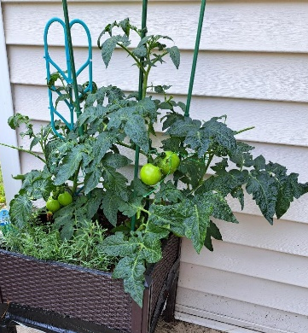
It’s that time of year again, time for home grown tomatoes. This is a photo of one of my container gardens sitting on my patio. The tomatoes are doing O.K. even though it seems to be taking them forever to ripen.
Since we are in “tomato” season, I thought it might be fun to share this story about tomatoes with you. Actually, the tomatoes were growing just outside the Garden of Eden. The story was written by Rabbi Marc Gellman who has a great imagination when it comes to stories from the Bible. This one is called, “ The Tomato Plant.”
The Garden of Eden had everything. Bears and monkeys, fish and butterflies—everything. Even the first man and woman. Adam and Eve were there. Nothing ever died in the garden, so of course nothing was ever born to replace it. The Garden of Eden had everything, but everything was always just the same.
One day Adam and Eve came upon a crack in the big wall that surrounded the garden. Looking through the crack, they saw that in the brown dust outside the garden a tomato plant was growing. At first they could hardly recognize it. In the garden, all the tomato plants were tall and full and green with many big red tomatoes on each stem. What they saw through the crack in the wall was a puny and shriveled up little thing with just one tiny green tomato barely hanging on to one of the stems.
Everyday Adam and Eve would come to the crack and peep through to see how the only thing growing outside the Garden of Eden was doing. One day the little tomato plant drooped over and turned brown. Adam looked at Eve and said, “It never looked good, but now it looks worse.” Eve looked at Adam and said, “Whatever could have happened to it?”
They sat there for a long time, peeping through the crack in the wall at the little tomato plant that had drooped over and turned brown.
After a long while, God spoke to them saying, “The tomato plant is dead.” Adam and Eve cried. They asked God, “Why did it have to die? Nothing dies here in the garden.” But God would not answer this question no matter how many times they asked.
So they became angry at God. They demanded that God let them out of the Garden of Eden so they could take care of the tomato plant. God said to them, “You can leave, but you can’t come back.” Well, Adam and Eve got up and walked right out of the garden and right over to the little tomato plant that had drooped over and turned brown. Inside the garden nothing needed help and even though outside the garden everything needed help, they were not sorry that they could not return.
Adam picked up the tiny green tomato and Eve planted it in the brown dust. For many days they watered the ground, kept the weeds away and waited.
Then it happened! A green shoot poked up through the dusty ground and in a few days it became a ….tomato plant! Full and green with many big red tomatoes on each stem!
In the days that followed, when the man and woman looked at the strong new tomato plant, they would also think of the scraggly little plant they had once peeked through the crack in the wall. It was a funny feeling. They were happy and sad at the same time.
Now that’s one version of Adam and Eve leaving the Garden of Eden. Who knows?
Perhaps what Rabbi Gellman wants us to understand is that from time to time we all have to risk leaving our familiar surroundings and step out in faith. Adam and Eve offered help to that lonely little tomato plant and it grew and flourished, bloomed and produced great tomatoes! Risk it from time to time, offer help to someone who needs love and care. Who knows what you might help produce!
Enjoy those home grown tomatoes. They’re great!
Blessings and Peace,
Pastor Diane

