July 5, 2026
Sixth Sunday after Pentecost
“All that we are, all that we have,
and all that we will become is a gift from God.”
Bold print invites all to speak or sing!

Gathering Music: “Medley of patriotic songs”

Call to Worship
The love of God makes us one body in Christ
As people of God, we are called together to be one,
to be led by the Spirit,
to be forgiven and forgiving,
to be grown in holiness,
to be bound into family.
Bound together, nothing can separate us from the love of God! So, let all the people say,
Amen!

Opening Hymn: “This Is My Song” No. 722

Opening Prayer
Loving God, your love for us is hidden and shown every day. You shimmer like a pearl in the love we experience; you flourish in our community; you bubble up, yeast like, in our midst. Gather us into the net of love which holds us as one large family with all creation. Amen.

Prayer of Confession
O God, we confess that we have turned away from you and haven’t lived with upright hearts. Forgive us for failing to follow you. Guide our feet to walk in your ways and serve your world. Amen.

Words of Assurance

Gloria Patri

Scripture readings: Genesis 29: 15-28 Matthew 13: 31-33, 44-52

Morning Message: “Promises, Promises”

Hymn: “I Love to Tell the Story” No. 480

Sharing our Joys and Concerns
Pastoral Prayer
Lord’s Prayer

A Prayer for the Nation No. 723

Presenting our Gifts

The Doxology

The Dedication Prayer
Promising God, who sees more than we see, help us to look into the eyes of those we serve, so that we may see how lovely they are. Help us to know your grace and beauty revealed in the eyes that are seen through these gifts. Amen.

Closing Hymn: “God of the Ages, Whose Almighty Hand” No. 725

Benediction
We have heard the promise:
Nothing can separate us from the love of God!
As we go out to make difficult decisions:
We know that nothing can separate us from the love of God!
As we go out to face illness or accidents or temptations or trials:
We know that nothing can separate us from the love of God!
Alleluia! Nothing can separate us from the love of God!
Nothing can separate us from the love of God! Alleluia!

Postlude: “Medley of patriotic songs”

Just a reminder: Please silence or turn off your cell phones during worship.
Pastor Diane Thomas
Pastor Phone: (928) 642-6676
Church Phone: (419) 683-2745
Pastor email: dsthomas18@ymail.com
Church email: crestlinecalvary@gmail.com
The church website: www.crestlinecalvary.com
You may view our worship service on YouTube

Attendance for June 28th was 20 adults.

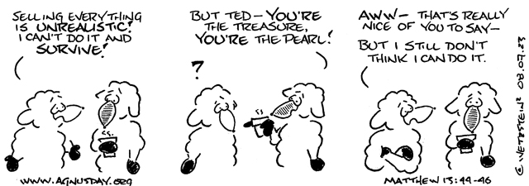

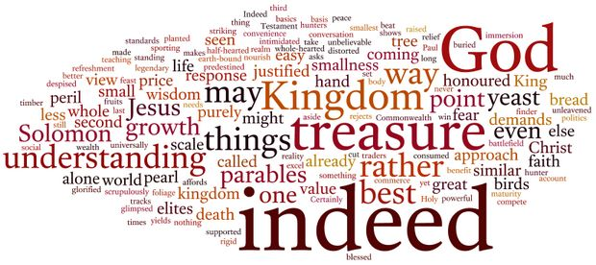
Welcome to Calvary
United Church of Christ
July 5, 2026
Sixth Sunday after Pentecost
“Serving God and Crestline Since 1859”
We welcome you and thank you for joining in worship!

