July 12, 2026
Seventh Sunday after Pentecost
“All that we are, all that we have,
and all that we will become is a gift from God.”
Bold print invites all to speak or sing!

Gathering Music: “Symphony No. 9 in E Minor” Dvorak

Call to Worship
The day breaks
And God does not let us go.
The hour calls
And God does not let us go.
The evening falls
And God holds us fast.
Let us turn to God in worship.
God, who never turns from us.

Opening Hymn: “O Worship the King” No. 17

Opening Prayer(unison)
God, you see us. You see our struggles. You see our difficulties. You see our possibilities. You see our promise. Call us in your wanderings to hear you say our names. For you are a good God, a God present in the struggle and in the end you always have a blessing. Amen.

Prayer of Confession
God of steadfast love some days aren’t easy and we don’t always find our way to you. We can struggle with despair and anxiety, unable to find a place of rest and peace. We allow petty arguments and hurts to take more energy than they deserve. We give in to fear and lose strength and let go of you. Forgive us. Amen.

Words of Assurance

Gloria Patri

Scripture readings: Psalm 17: 1-7, 15 Genesis 32: 22-31

Morning Message: “Out of Joint”

Hymn: “How Great Thou Art” No. 33

Sharing our Joys and Concerns
Pastoral Prayer
Lord’s Prayer

Presenting our Gifts

The Doxology

The Dedication Prayer
May this act of giving bring about change: change in our lives, change in the lives we touch, change in the systems that harm. Through Christ who gave so much to save. Amen.

Closing Hymn: “More Love to Thee, O Christ” No. 527

Benediction
We know we have met God face to face because we have seen the ordinary shining with blessing.
God’s face is revealed in all creation.
We know we have met God face to face because we have been empowered to share abundantly.
God’s face is revealed in all creation.
We know we have met God face to face because we have been inspired to proclaim the blessings we receive from the ordinary love of friends and family.
God’s face is revealed in all creation.
We go out together to show others the face of God, in words, in acts of service and forgiveness.
Amen.

Postlude: “Pie Jesu” Faure

Attendance for July 5th was 17 adults.

Just a reminder: Please silence or turn off your cell phones during worship.
Pastor Diane Thomas
Pastor Phone: (928) 642-6676
Church Phone: (419) 683-2745
Pastor email: dsthomas18@ymail.com
Church email: crestlinecalvary@gmail.com
The church website: www.crestlinecalvary.com
You may view our worship service on YouTube

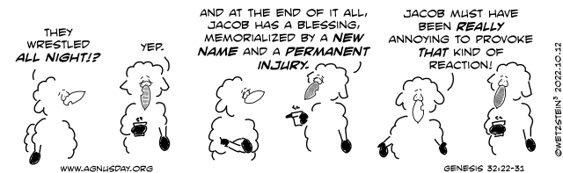


Welcome to Calvary
United Church of Christ
July 12, 2026
Seventh Sunday after Pentecost
“Serving God and Crestline Since 1859”
We welcome you and thank you for joining in worship!

