July 26, 2026
Ninth Sunday after Pentecost
“Christmas in July”
“All that we are, all that we have,
and all that we will become is a gift from God.”
Bold print invites all to speak or sing!

Gathering Music:

Call to Worship
We come from the darkness of our night into the light of God’s day
We come from our yesterdays, journeying into God’s tomorrow.
We come from this place in time and space to worship the One who, from everlasting, is God—
The One who is Alpha and Omega, the beginning and the end: a lamp to our pathway and a light to the world.
Come let us worship!

Christmas Carol: Congregational Choice

Opening Prayer
Most gracious God, you are present with us even when we are overwhelmed with busyness and frustration. Grant us the quietness and patience to listen for your creative word in our lives, to see the vision you offer in the lives and words of your prophets, and especially in the life and teaching of your Beloved Child, Christ Jesus. Amen.

Prayer of Confession
O God, whose Spirit works in us, calling us to be a faithful community: We confess how often we have not looked to you for wisdom and power for living. We look to the world for our messiahs, seeking security in the things we own, in the prejudices and opinions we have acquired. We are rich in the eyes of the world yet poor in faith. Forgive us God. May we let go and let you make us worthy of being called the Church of Jesus Christ. Amen.

Words of Assurance

Gloria Patri

Scripture readings: Isaiah 11: 1-10 John 1: 1-5, 14

A Christmas Carol: Congregational Choice

A Christmas Story: The Last Straw by Fredrick H. Thury

A Christmas Carol: Congregational Choice

Sharing our Joys and Concerns
Pastoral Prayer
Lord’s Prayer

Presenting our Gifts

The Doxology

The Dedication Prayer
In times of struggle, God, you call us to give support; in times of uncertainty you call us to offer a clear vision; in times of despair you call us to speak a word of hope. Bless the good in all we give and bless these gifts that they may bring closer your dream of justice and peace. Amen.

A Christmas Carol: Congregational Choice

Benediction
The world has not stood still while we have been worshipping.
And now we return to the world.
In our busyness may we know the peace of God.
In our struggles may we know the grace of Christ.
In our striving to be faithful may we know the enabling of the Holy Spirit.
We go in hope asking God’s blessing who is ever faithful. Amen.

Postlude:

Attendance for July 12th was 19 adults.
Attendance for July 19th was 17 adults.

Just a reminder: Please silence or turn off your cell phones during worship.
Pastor Diane Thomas
Pastor Phone: (928) 642-6676
Church Phone: (419) 683-2745
Pastor email: dsthomas18@ymail.com
Church email: crestlinecalvary@gmail.com
The church website: www.crestlinecalvary.com
You may view our worship service on YouTube

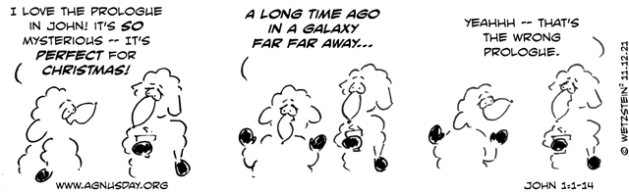


Welcome to Calvary
United Church of Christ
July 26, 2026
Ninth Sunday after Pentecost
Christmas in July
“Serving God and Crestline Since 1859”
We welcome you and thank you for joining in worship!

