August 2, 2026
Tenth Sunday after Pentecost
“All that we are, all that we have,
and all that we will become is a gift from God.”
Bold print invites all to speak or sing!

Gathering Music: Rondeau Mouret

Call to Worship
Praise God for calling us together.
Praise!
Praise God for calling sisters and brothers all over the earth into one family.
Praise!
Praise God for welcoming everyone into God’s own realm of peace.
Praise!

Opening Hymn: “Immortal, Invisible, God Only Wise” No. 66

Opening Prayer
Holy One of Israel, covenant-keeper, you restore what is lost, heal what is wounded and gather in those who have been rejected. Give us the faith to speak as steadfastly as did the Canaanite woman, that the outcast may be welcomed and people may be blessed. Amen.

Prayer of Confession
Merciful God, so often we try to go it on our own lacking faith in you. We fail to recognize your work in the faith of others. We confess that we need to be drawn into right relationship with you and each other. Hear us O God, forgive us. Amen.

Words of Assurance

Gloria Patri

Scripture readings: Isaiah 56: 1, 6-8 Matthew 15: 21-28

Message: “Speaking Up”

Hymn: “What a Friend We Have in Jesus” No. 585

Sharing our Joys and Concerns
Pastoral Prayer
Lord’s Prayer

Presenting our Gifts

The Doxology

The Dedication Prayer
Gracious God, you have given us more blessings than we could imagine. Receive now these gifts as part of our gratitude to you. May your grace filled blessings be multiplied to embrace all those in need. Amen.

Closing Hymn: “Help Us Accept Each Other” No. 487

Benediction The Prayer of St. Francis
Lord, make me an instrument of your peace.
Where there is hatred, let me show love.
Where there is division, unity.
Where there is error, truth.
Where there is injury, pardon.
Where there is doubt, faith.
Where there is despair, hope.
Where there is darkness, light.
Where there is sadness, joy.
O divine master, grant that I may not so much seek to be consoled as to console.
To be understood, as to understand, to be loved, as to love.
For it is in the giving that we receive. It is in the pardoning that we are pardoned. It is in the dying that we are born to eternal life. Amen.

Postlude: Largo Handel

Attendance for July 26th was 27adults.

Just a reminder: Please silence or turn off your cell phones during worship.
Pastor Diane Thomas
Pastor Phone: (928) 642-6676
Church Phone: (419) 683-2745
Pastor email: dsthomas18@ymail.com
Church email: crestlinecalvary@gmail.com
The church website: www.crestlinecalvary.com
You may view our worship service on YouTube

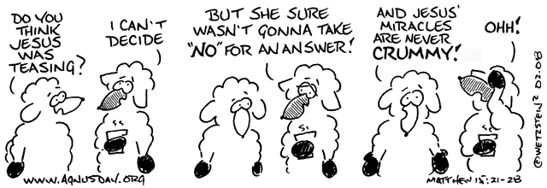

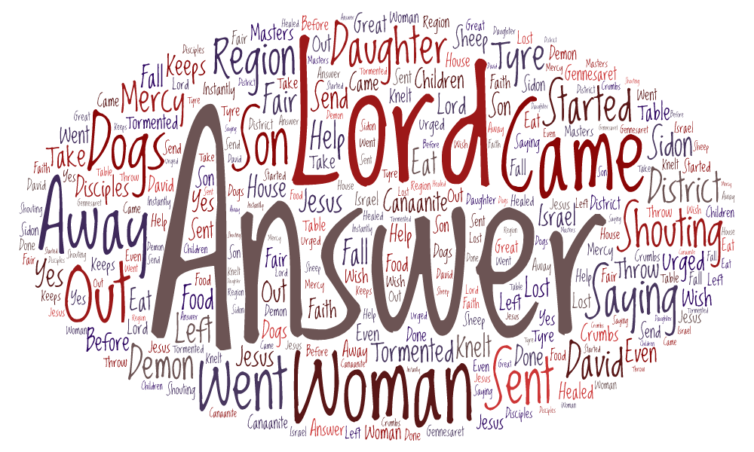

Welcome to Calvary
United Church of Christ
August 2, 2026
Tenth Sunday after Pentecost
“Serving God and Crestline Since 1859”
We welcome you and thank you for joining in worship!

