August 16, 2026
Twelfth Sunday after Pentecost
All that we are, all that we have,
and all that we will become is a gift from God.”
Bold print invites all to speak or sing!

Gathering Music “Morning Has Broken Medley arr Wells

* Call to Worship (responsive)
In the gathering of school supplies,
In the harvesting of backyard gardens;
God blesses us beyond imagination.
In the simple act of daily chores,
In the kindness shared by a stranger:
God is gracious to us.
In the rapture of a child watching a firefly,
In the inquisitive look of a senior
Wondering where they left their keys:
God’s face shines upon us.
We praise you, O God!
We praise you!

*Opening Hymn: “This Is My Song” No. 722

*Opening Prayer

Welcoming God: you gather everyone, especially the outsiders, to worship
you, for you are not an image or an idol, but protector or the helpless,
parent to the poor, friend of the lonely. Accepting Christ: there is not any
place you will not go to bring God’s grace to others. In you, the enemy is
made a friend, the broken are made whole, the orphan finds a home.
embracing Spirit: your gentleness falls upon us, and our fears of rejection
disappear; your truth is whispered in our ears, and our arms embrace
strangers; your peace is poured into our souls; and we are reconciled to all we hurt; your love throws open our shuttered hearts, and we see our siblings
all around us. God in Community, Holy in One, in you we have life and hope
forever. Amen.

*Prayer of Confession (all)
In every opportunity, God of this day, we choose not to follow you. From our hearts to our mouths flow words that hurt others, come thoughts that lead us away from you. We are richly blessed, but think others should be
grateful for the crumbs we offer them. Our claims to have great faith are
disputed by our inability to trust you in all things.
We come to you, Helper of the weak, for you are gracious and
forgiving. You offer us the fullness of your love, not just a few dollops. You
refuse to let us go, but sweep us up with arms of joy. You send Jesus Christ,
our Lord and Savior, to lead us into your kingdom. Amen.

*Words of Assurance

* Gloria Patri No. 35

Scripture Readings: Genesis 45: 1-15 Matthew 15: 10-20

Message: “What Comes from the Heart”

Hymn: “We Gather Together” No. 276

Sharing our Joys and Concerns
Morning Prayer and the Lord’s Prayer

Presenting our gifts

* The Doxology

* The Dedication Prayer
Just as we would not offer crumbs to the hungry, may we not offer just our
pocket change, Holy One. May our gifts become grace, hope, justice, and
love to all around us. In Jesus’ name we pray. Amen.

* Closing Hymn “Here I am Lord“” No. 452

* Benediction
Sending
Now go, to serve as God’s people.
We will work to remove all that divides us from others.
Now go, to share the grace of Jesus.
We will love others just as we are loved.
Now go, to be the Spirit’s community.
We will invite everyone to join us in this life of faith and service.

Postlude: Blessings Brickman

Attendance for Aug. 9th was 15 adults.

Just a reminder: Please silence or turn off your cell phones during worship.

Pastor Diane Thomas
Pastor Phone: (928) 642-6676
Church Phone: (419) 683-2745
Pastor email: dsthomas18@ymail.com
Church email: crestlinecalvary@gmail.com
The church website: www.crestlinecalvary.com
You may view our worship service on our website.

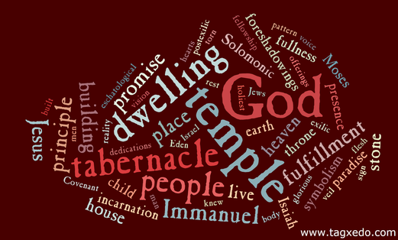

Welcome to Calvary
United Church of Christ
August 16, 2026
Twelfth Sunday after Pentecost
“Serving God and Crestline Since 1859”
We welcome you and thank you for joining in worship!

