August 9, 2026
Eleventh Sunday after Pentecost
“All that we are, all that we have,
and all that we will become is a gift from God.”
Bold print invites all to speak or sing!

Gathering Music: Peace in the Valley Dorsey

Call to Worship
Jesus comes to us, showing us how to do the unlikely.
Come, Jesus says: trust me.
Jesus calls us to leave the boat to risk the waves.
Come, Jesus says: trust me.
Jesus calls us to rise from quiet prayer to risk the storms of witness.
Come, Jesus says: trust me.
Jesus calls us to rise from the gravity of doubt to risk the levity of faith.
Come, Jesus says: trust me.
Come, he says, come from safety to miracle.
Come, Jesus says: trust me

Opening Hymn: “O for a Thousand Tongues to Sing” No. 5

Opening Prayer
God of presence, as you walked upon water to meet the disciples, meet us in the midst of the storms of our lives. God of renewal, direct us in your way, work out your purpose in and through us. Amen.

Prayer of Confession
God, we confess that we don’t always understand your ways. We are easily discouraged and quick to give up when things get difficult. We are quick to question your presence and power. All too often we just want to have life go our way, living comfortable and safe lives. Forgive us, open our eyes to recognize you leading us even when we can’t see the outcome. Amen.

Words of Assurance

Gloria Patri

Scripture readings: Psalm 85: 8-13 Matthew 14: 22-33

Message: “Sink or Swim”

Hymn: “Jesus Calls Us O’er the Tumult” No. 337

Sharing our Joys and Concerns
Pastoral Prayer
Lord’s Prayer

Presenting our Gifts

The Doxology

The Dedication Prayer
Loving God, you save and protect us. Take all that we offer—our gifts and ourselves and use them to make known your great works of justice among all people and proclaim the good news of your never-ending love. In the name of Christ our Redeemer who calms our deepest fears. Amen.

Closing Hymn: “Jesus, the Very Thought of Thee” No. 102

Benediction
Give thanks to God who lives in the whirlwind and calms the storms.
Thanks be to God.
Give thanks to God who is with us when we sink in despair and who lifts us into joy again.
Thanks be to God.
Give thanks to God that we have received this good news.
Thanks be to God.
Give thanks to God that we are sent to bear the good news to others.
Thanks be to God

Postlude: Precious Lord Dorsey

Attendance for June 2nd was 21 adults.

Next Sunday we will celebrate the sacrament of Holy
Communion during worship.

Consistory will meet next Sunday morning following worship.

Just a reminder: Please silence or turn off your cell phones during worship.
Pastor Diane Thomas
Pastor Phone: (928) 642-6676
Church Phone: (419) 683-2745
Pastor email: dsthomas18@ymail.com
Church email: crestlinecalvary@gmail.com
The church website: www.crestlinecalvary.com
You may view our worship service on YouTube



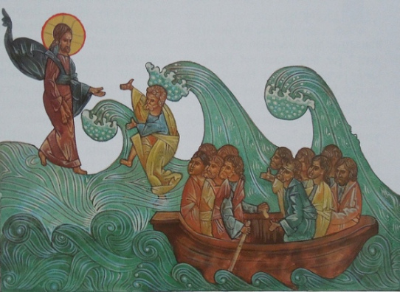

Welcome to Calvary
United Church of Christ
August 9, 2026
Eleventh Sunday after Pentecost
“Serving God and Crestline Since 1859”
We welcome you and thank you for joining in worship!

