August 23, 2026
Thirteenth Sunday after Pentecost
“All that we are, all that we have,
and all that we will become is a gift from God.”
Bold print invites all to speak or sing!

Gathering Music: “Canon in G” Brickman

Call to Worship
Come from what is familiar, what is usual, what is comfortable, what you’ve always done, what the world demands.
Look inward to what is dormant, what is hidden, what is undeveloped, look for potential,
the improbable, yet possible, the unpredictable, yet imaginable. Work for the transformative, the life-changing, the abundantly new, the revolutionary, the holy.
Choose the holy.

Opening Hymn: “God of Grace and God of Glory” No. 464

Opening Prayer
Creator God, you make us all different, giving to each one of us special and wonderful gifts, inviting and challenging us to share who and what we are for the good of the community. In the beauty of our differences remind us that we are one. In this time of worship help us to celebrate the Body of Christ and the special place each one of us has in that body. Amen.

Prayer of Confession
Forgiving God, we confess that we are conformed to this world. We conform to the world’s shallow values, oblivious to the giftedness of people different from us. We conform to this world’s impatient attitudes, preferring the latest instead of the lasting. Forgive us, transform us, O God. Amen.

Words of Assurance

Gloria Patri

Scripture readings: Romans 12: 1-8 Matthew 16: 13-20

Message: “Bring Out the Best”

Hymn: “Love Divine, All Loves Excelling” No. 517

Sharing our Joys and Concerns
Pastoral Prayer
Lord’s Prayer

The Doxology

Presenting our Gifts

The Dedication Prayer
Gracious God, we thank you for the gifts you have given each of us. Increase in us generosity, compassion and courage so that we may continue to be your body in and for the world. With thanksgiving we pray. Amen.

Closing Hymn: “I Have Decided to Follow Jesus” No. 344

Benediction
As the Church, Christ’s body on earth,
God sends us out into the world.
God has blessed each one of us with gifts and talents and calls us to share them.
We are the Church, Christ’s body on earth, we go to serve.
Go forth to experience God’s mercy.
We will go forth to practice God’s mercy. Amen.

Postlude: “Jesus is the Sweetest Name Medley” arr. Davis

Attendance for Aug.16th was 17 adults.

Just a reminder: Please silence or turn off your cell phones during worship.
Pastor Diane Thomas
Pastor Phone: (928) 642-6676
Church Phone: (419) 683-2745
Pastor email: dsthomas18@ymail.com
Church email: crestlinecalvary@gmail.com
The church website: www.crestlinecalvary.com
You may view our worship service on YouTube

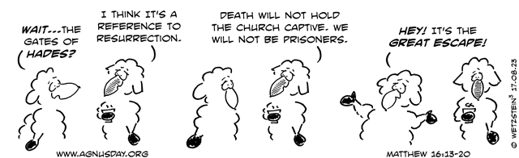

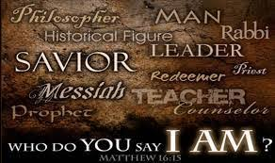

Welcome to Calvary
United Church of Christ
August 23, 2026
Thirteenth Sunday after Pentecost
“Serving God and Crestline Since 1859”
We welcome you and thank you for joining in worship!

