August 30, 2026
Fourteenth Sunday after Pentecost
“All that we are, all that we have,
and all that we will become is a gift from God.”

Gathering Music: “Great is Thy Faithfulness” Runyan

Call to Worship
Seek God, seek God’s presence continually.
Turn aside here to seek God, to seek God’s presence.
Look closer. Look and listen.
Turn aside from the familiar path and say, “Here I am.”
Come. Stand here. Stand on holy ground.
Look, listen. We stand on holy ground.

Opening Hymn: “All People That on Earth Do Dwell” No. 18

Opening Prayer
God of all earth and sky, you shaped us from your own ground into being. You breathed word into our ears. You burn around us in unexpected places, calling us to turn aside and feel your presence, to turn aside and hear your voice, to turn aside and be grounded in you. Here we are, Holy God; open, waiting, hoping to know you more deeply, more fully, more wholly. Amen.

Prayer of Confession
In this season of sun and warmth O God we confess those times when we have been cool in relationships and distant in friendships. We confess those times when we haven’t let go of attitudes that cut others off. We confess those time when we have hoarded your gifts and turned away from those in need. O God, coax us into newness, into wholeness, into life. Amen.

Words of Assurance

Gloria Patri

Scripture readings: Exodus 3: 1-15

Message: “I Am Who I Am”

Hymn: “Go Down, Moses” No. 663

Sharing our Joys and Concerns
Pastoral Prayer
Lord’s Prayer

The Doxology

Presenting our Gifts

The Dedication Prayer
In your Creation, O God, we stand on the holiest of ground. May these gifts be a blessing to all. May the church, organizations and people that receive them act as your hands. May needs be seen and met and may the giving fit the need. Through Christ who models infinite giving. Amen.

Closing Hymn: “God, Dismiss Us with Your Blessing” No. 439

Benediction
God calls us to dream new dreams.
God sends us to gather the outcast, to feed the hungry, to heal the wounded.
God calls us to shout the truth, to whisper forgiveness,
to build peace, to break fetters, to lead journeys.
God calls us. God calls you, God calls me.
We go in the name of God. Amen.

Postlude: “Now the Day is Over” Davis

Attendance for Aug.23rd was 18 adults.

Just a reminder: Please silence or turn off your cell phones during worship.
Pastor Diane Thomas
Pastor Phone: (928) 642-6676
Church Phone: (419) 683-2745
Pastor email: dsthomas18@ymail.com
Church email: crestlinecalvary@gmail.com
The church website: www.crestlinecalvary.com
You may view our worship service on YouTube

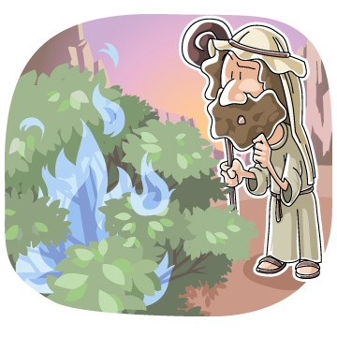

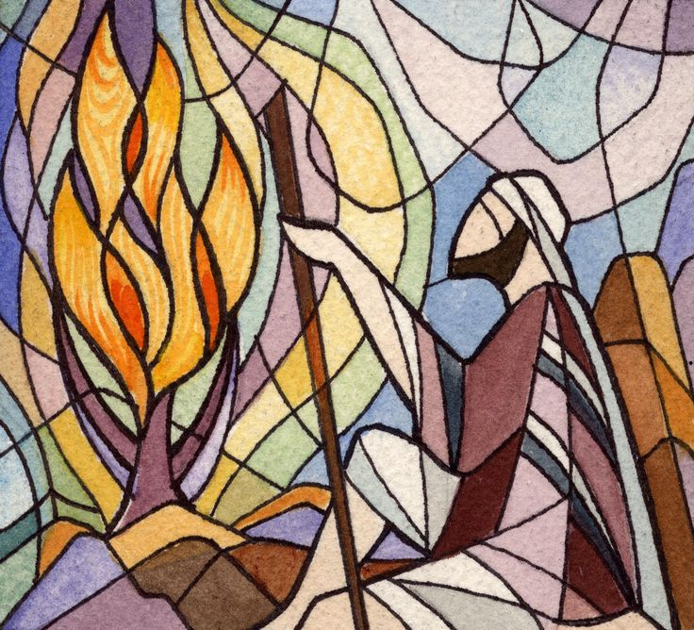

Welcome to Calvary
United Church of Christ
August 30, 2026
Fourteenth Sunday after Pentecost
“Serving God and Crestline Since 1859”
We welcome you and thank you for joining in worship!

