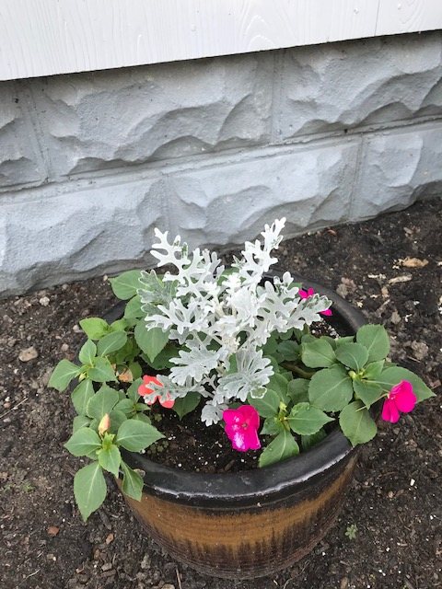
It’s a Miracle!
(reprinted from 8/25/21)
So often we tell ourselves there just aren’t any miracles anymore. Certainly not the sort that Jesus was able to perform. We think about his miracle healing powers, his feeding of thousands of people with just two fish and five tiny loaves, or how Jesus was able to walk on water, and of course miracle of miracle Christ’s resurrection. Those sorts of miracles don’t happen, at least not in our lifetime.
But….there are miracles going on all around us, we just need to pay attention.
This beautiful pot of flowers once stood outside the entrance to our sanctuary. Unfortunately, it had lost much of its bloom so to speak. The plant was droopy, the flowers were dying, but the weeds were doing fine.
Early in August, Cathy Strauch took pity on the poor pot and its flowers. She took the pot of flowers home and began to nurse it back to health. She watered, weeded and tended to the plant, adding some Miracle Gro for good measure. Look at the plant today! Amazing what a bit of care and attention can do.
So, perhaps there’s a lesson here for us, not just about tending to our gardens, but about miracles we can accomplish.
These days it seems that all we hear around us is fear and dislike. Entire groups of people are singled out and blamed for all sorts of problems and disasters. We’re still facing the challenge of the pandemic. Natural disasters, earthquakes, floods, wildfires are happening every day. We may feel as though we’re wading through a lot of muck and mire, with no end in sight.
Yet, maybe it’s not as bleak as we think. Miracles can happen, small miracles. Every time we reach out to a stranger or neighbor in need, whenever we provide a listening ear or encouraging word, even a smile or small gesture of kindness is a miracle. And we can do these things; we can create miracles if we try.
So, this week as you’re out and about or tending to all sorts of tasks at home, think about the miracles you’ve accomplished perhaps without even knowing. And think about the miracles you’ve received from friends, neighbors and strangers.
After all, as someone once said, “It’s the little things that count.”
Enjoy the blooms around us.
Blessings and Peace,
Pastor Diane

