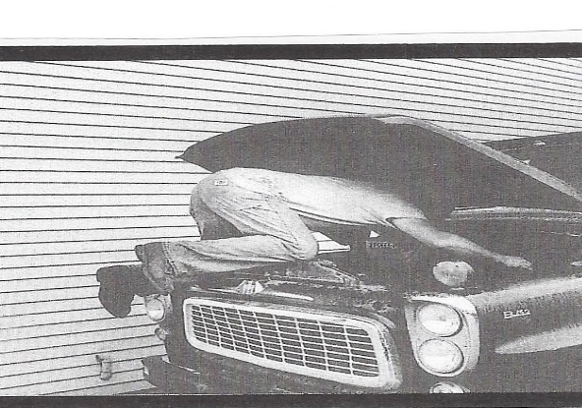

This reflection/meditation is one I’ve shared with you a few years ago. It’s written by Kathy Wonson Eddy. I think this message is one that should be repeated and remembered.
These days, most of our cars don’t look at all like this one. This picture is most certainly from the past. Now our cars are loaded with all sorts of computers that are supposed to keep our vehicles running and those who work on our cars have to be computer savvy to say the least.
Nevertheless, I think we can relate to what Kathy Eddy observed from this photo. She says that for a long time she kept this photo on her desk so she would see it every day. She writes that she needed to look at it whenever she felt a lack of focus and energy. Whenever she thought she needed renewed commitment for her work, the image seemed to remind her that it was time for her to roll up her sleeves and get into it.
Eddy writes this, “To give our full attention, our energy, our particular gifts, our time brings rich rewards beyond our most extravagant dreams. Our call is to spend our love with delight, not hold it back. It is God who gives us the strength of mind and body to offer ourselves freely. It is God who places in us renewed desire to care with depth and fullness.”
Edddy also says this. “The mechanic’s body language communicates that he is offering his best to this task: he is intensely focused and giving all he can. Jesus taught that when we give this way the blessings come flowing back to us.
Consider this passage of scripture. It comes from the gospel of Luke 6: 3-8
“Give and it will be given you. A good measure, pressed down, shaken together, running over, will be put into your lap; for the measure you give will be the measure you get back.”
Indeed, we should be giving ourselves “full measure” to our tasks, or whatever endeavor we take on. And giving “full measure” also carries with it the expectation that we give what we have without holding back.
Share ourselves, willingly and happily. That’s what it’s all about.
May we all learn from this mechanic who is giving it his all. God has gifted us with abundance, it’s up to us to share without reservation.
Blessings and Peace,
Pastor Diane

