September 13, 2026
Sixteenth Sunday after Pentecost
“All that we are, all that we have,
and all that we will become is a gift from God.”

Gathering Music: “Amazing Grace” Harmony

Call to Worship
Come if you have a weak faith. If you’re convinced in the strength of your convictions. Come so that you might be strengthened and challenged.
Lead us into life, O God!
Come if you are chased by the demands of others. Come if you feel threatened by a loss of security. Come so that you might be strengthened and challenged.
Lead us into life, O God!
Come if you need forgiveness. Come if you need strength to forgive others. Come so that you might be strengthened and challenged.
Lead us into life, O God!

Opening Hymn: “You Servants of God” No. 110

Opening Prayer
Loving God, in this world of much brokenness, we come seeking the comfort of your presence. Our hearts long for the joy of living lives of love and forgiveness, joy and truth. Open our hearts that we may be moved by your Spirit who seeks a home within us. Amen.

Prayer of Confession
Gracious God, we confess that we have not listened for your word among the clamor of words all around us. We try harder to defend what we think we know than to reach for that which is beyond our grasp. We cling to old ways of blaming and finger pointing that make it difficult to forgive. Teach us how to find words of love, compassion and acceptance. May your Spirit enable us to love one another. Amen.

Words of Assurance

Gloria Patri

Scripture readings: Romans 14: 1-12 Matthew 18: 21-36
Message: “How Many Times?”

Hymn: “I Love to Tell the Story” No. 480

Sharing our Joys and Concerns
Pastoral Prayer
Lord’s Prayer

The Doxology

Presenting our Gifts

The Dedication Prayer
You taught us to live in peace and gratitude O God. We bring you our offerings because you have known peace, your blessings and love. We offer our thanks and joy through these gifts. Bless them, we pray and may the gifts of your blessings be multiplied in your Spirit. May others know of your blessings and grace. Amen.

Closing Hymn: “Take My Life” No.609

Benediction
God calls us to forgiveness.
God calls us to live a life of freedom.
Peace,
Joy,
and dignity
for all our brothers and sisters around the world.
Let us go into the world with God’s eternal spirit that longs to bring the world back to God in joy.
Amen.

Postlude: “O How I Love Jesus” Curry

Attendance for Sept.6th was 17 adults.

Next Sunday we will resume worship in the sanctuary.

Just a reminder: Please silence or turn off your cell phones during worship.
Pastor Diane Thomas
Pastor Phone: (928) 642-6676
Church Phone: (419) 683-2745
Pastor email: dsthomas18@ymail.com
Church email: crestlinecalvary@gmail.com
The church website: www.crestlinecalvary.com

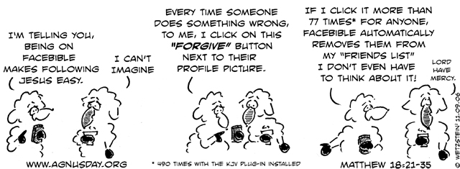

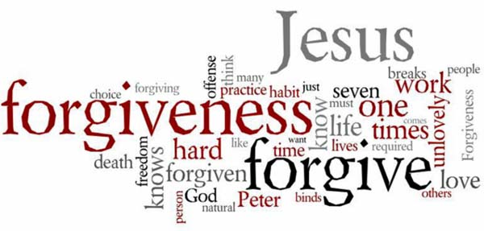
Welcome to Calvary
United Church of Christ
September 13, 2026
Sixteenth Sunday after Pentecost
“Serving God and Crestline Since 1859”
We welcome you and thank you for joining in worship!

