September 20, 2026
Seventeenth Sunday after Pentecost
“All that we are, all that we have,
and all that we will become is a gift from God.”
*Indicates all who can, please stand

Gathering Music: “Meditation” Clarke

*Call to Worship
God breathed life into human beings made in God’s image.
We remember. So let’s give God the glory!
God called Moses to lead God’s people out of slavery
We remember. So let’s give God the glory!
God, like a pillar of clouds led the people through the sea to freedom.
We remember. So let’s give God the glory!
God gives us a way when there seems to be no way.
We remember. So we worship today.

*Opening Hymn: “We Gather Together” No. 276

*Opening Prayer
O God, turn our faces, our voices and our lives toward you, so that we might know goodness, receive what we most need and share the gifts of life with others. Amen.

*Prayer of Confession
O God, when we are afraid of what lies ahead and want to go back to the old ways instead of seeking your new way with us, forgive us. When we complain, when we blame others, forgive us. When we have more than enough and want even more, forgive us. When we forget your goodness, forgive us and open ourselves to you. Our hands are open to receive your gifts. Amen.

*Words of Assurance

*Gloria Patri

Scripture readings: Exodus 16: 2-15 Matthew 20: 1-16

Message: “Grumble, Grumble, Grumble”

Hymn: “Lead On, O Cloud of Presence” No. 633

Sharing our Joys and Concerns
Pastoral Prayer
Lord’s Prayer

Presenting our Gifts

*The Doxology

*The Dedication Prayer
We offer you these gifts, O God, trusting that when added to the bounty of your love, they can make a difference in our world. O God, we trust in your spirit to strengthen and sustain us, as we strive to live in the light of your grace. Amen.

*Closing Hymn: “Glorious Things of Thee Are Spoken” No. 709

* Benediction
We have been fed by the stories of faith
We turn our faces into the uncertain places so we may know God.
We have been sustained in the rituals of community.
We turn our lives back to the God of plenty.
May the God of bread and justice accompany us.
May the Spirit surround us with hope as we walk the way of Christ. Amen.

Postlude: “The Master Has Called Us” Peterson

Consistory will meet this morning following worship.

Attendance for Sept.13th was 20 adults.

Just a reminder: Please silence or turn off your cell phones during worship.
Pastor Diane Thomas
Pastor Phone: (928) 642-6676
Church Phone: (419) 683-2745
Pastor email: dsthomas18@ymail.com
Church email: crestlinecalvary@gmail.com
The church website: www.crestlinecalvary.com

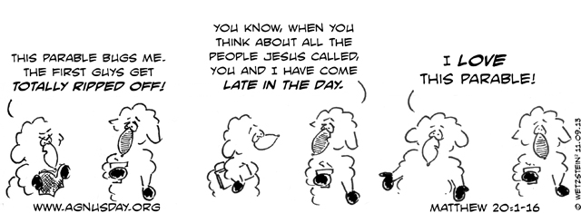

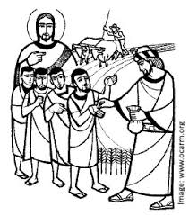
Welcome to Calvary
United Church of Christ
September 20, 2026
Seventeenth Sunday after Pentecost
“Serving God and Crestline Since 1859”
We welcome you and thank you for joining in worship!

