September 27, 2026
Eighteenth Sunday after Pentecost
“All that we are, all that we have,
and all that we will become is a gift from God.”
*Indicates all who can, please stand

Gathering Music: “Blessed Assurance” Knapp

*Call to Worship
Watch and listen for the wonders of our God.
Our God is among us.
Watch and listen for the goodness of our God.
Our God moves among us.
Watch and listen, for God is here.
Our God dwells among us.

*Opening Hymn: “Praise to the Lord, Almighty” No. 25

* Opening Prayer
God of community, who binds us together in mutual respect and love. We don’t seek righteousness or piety, fancy words or ornate actions. We humbly and reverently seek to be in deeper relationship with you and offer our awe and respect as best we know how. Amen.

* Prayer of Confession
God of harvests and new beginnings. We confess those things that keep us from the life you offer. We bring what is hurtful and unfinished, failures and angry moments and tasks undone. We bring our resistances and pride that keep us from asking forgiveness. Unburden us, lighten us, free us, grant us forgiveness. Amen.

*Words of Assurance

*Gloria Patri

The Choir: “Bringing In the Sheeves”

Scripture readings: Philippians 2: 1-13 Matthew 21: 23-32

Message: “Who Do You Think You Are?”

Hymn: “Softly and Tenderly” No. 340

Sharing our Joys and Concerns
Pastoral Prayer
Lord’s Prayer

Presenting our Gifts

*The Doxology

*The Dedication Prayer
Generous God, you give to us continuously. You nurture us through the beauty of Creation, through the care of all people and the inner voice of love. May these gifts be a blessing as we join with our brothers and sisters around the world, as we join our hearts and minds in creating a world you long for us to create in your name. Amen.

*Closing Hymn: “Bless Be the Tie That Binds” No. 433

* Benediction
May the things we do
match the things we say.
May the things we say,
match the things we do.
May our living each day,
match your Holy way.
Bless us, God and bless all that we do, say and pray.
Amen.

Postlude: “Promenade” Young

Attendance for Sept.20th was 20 adults.

Choir practice will be held this Wednesday evening at 7:00

Next Sunday we will celebrate the sacrament of Holy Communion

Just a reminder: Please silence or turn off your cell phones during worship.
Pastor Diane Thomas
Pastor Phone: (928) 642-6676
Church Phone: (419) 683-2745
Pastor email: dsthomas18@ymail.com
Church email: crestlinecalvary@gmail.com
The church website: www.crestlinecalvary.com

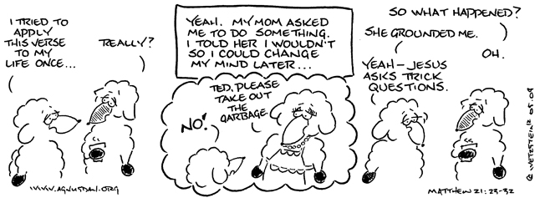

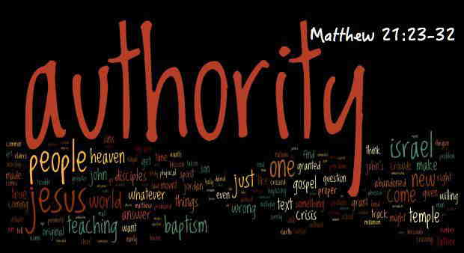

Welcome to Calvary
United Church of Christ
September 27, 2026
Eighteenth Sunday after Pentecost
“Serving God and Crestline Since 1859”
We welcome you and thank you for joining in worship!

