October 4, 2026
Nineteenth Sunday after Pentecost
World Communion Sunday
“All that we are, all that we have,
and all that we will become is a gift from God.”
*Indicates all who can, please stand

Gathering Music: “At the Cross” Hudson

*Call to Worship (based on Psalm 19)
The law of God is perfect.
Reviving the soul.
The decrees of God are right.
Rejoicing the heart.
The commandments of God are clear.
Enlightening our spirits.
The heavens are telling the Glory of God.
Let us proclaim God’s handiwork in praise and worship.

*Opening Hymn: “Immortal, Invisible, God Only Wise” No. 66

* Opening Prayer
God of community, who holds us together in mutual respect and love. We do not seek righteousness or piety, fancy words and ornate actions, we humbly and reverently seek to be in deeper relationship with you and to offer our awe and respect as best we know how. Amen.

* Prayer of Confession
God of love, too often we fail to show respect to all your creation, we mistreat and abuse the gifts you have given us, we neglect to reap a past generation’s harvest, we fail to live by your way. Forgive us so that the words of our mouths and the meditations of our hearts may always be acceptable to you, our God, Rock and Redeemer. Amen.

*Words of Assurance

*Gloria Patri

The Choir: “Let Us Break Bread Together”
Scripture readings: Exodus 20: 1-4, 7-9, 12-20 Philippians 3: 4b-14

Message: “Having It All”

Hymn: “Wonderful Words of Life” No. 323

Sharing our Joys and Concerns
Pastoral Prayer
Lord’s Prayer

Presenting our Gifts

*The Doxology

*The Dedication Prayer
Stir within us, Spirit of the living God, that our lives may carry the spirit of your law. May our finest offerings flow through these gifts into the world you love. Amen.

*Communion Hymn: “One Bread, One Body” No. 393

Invitation to Communion
Words of Institution, Consecration, Sharing the Elements

*Prayer of Thanksgiving
Gracious God, we thank you for this meal and for all the ways you nourish us. Grow in us so that we may nourish others. Sustain us as we press toward the goal of your call in Christ Jesus. Amen.

*Closing Hymn: “God Be with You Till We Meet Again” No. 434

* Benediction
Go into the world as people shaped into a true community of love and care.
We go from this time and place attuned to the spirit of God’s law.
In the noises and uncertain silences, be people who delight in what is good.
We are alive to the sounds of God and seek to be holy and whole to the glory of God blessing of our neighbors and the sake of the world. Amen.

Postlude: “I’d Like to Teach the World to Sing” Bockey, Davis,
Cook, Greenaway

Choir practice will be held this Wednesday evening at 7:00

Attendance for Sept. 27th was 20 adults.

We will begin a new Bible Study on Wednesday, October 21 at 5:30pm. Our study guide is Light of the World. Come and join us as we begin an early exploration of the season of Advent.

Just a reminder: Please silence or turn off your cell phones during worship.
Pastor Diane Thomas
Pastor Phone: (928) 642-6676
Church Phone: (419) 683-2745
Pastor email: dsthomas18@ymail.com
Church email: crestlinecalvary@gmail.com
The church website: www.crestlinecalvary.com



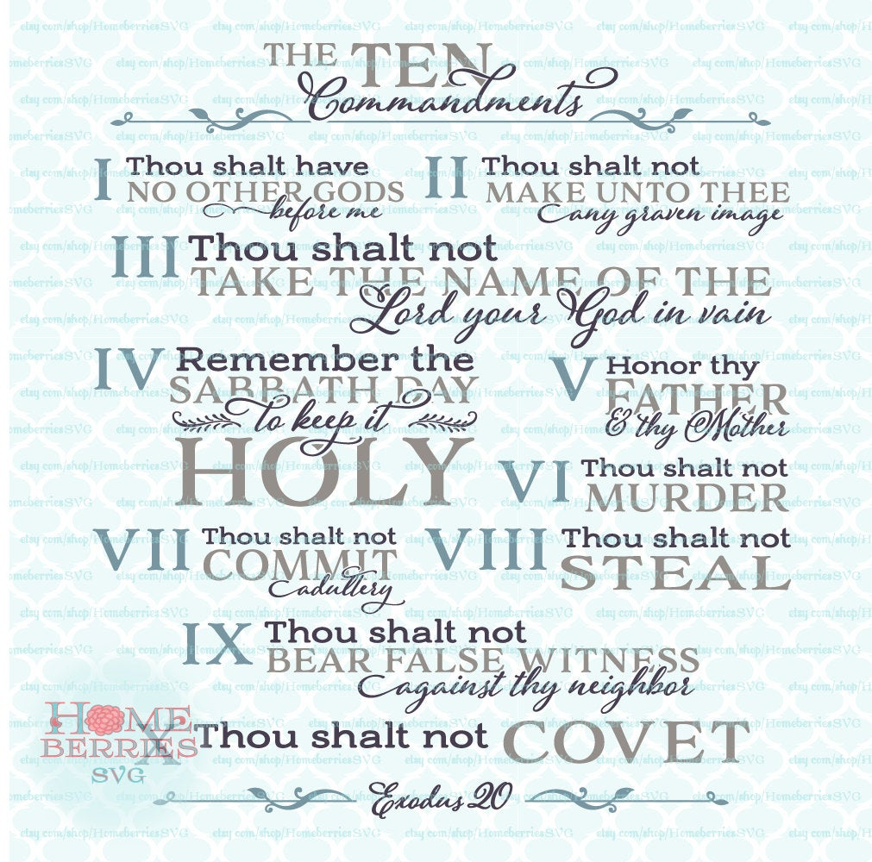

Welcome to Calvary
United Church of Christ
October 4, 2026
Nineteenth Sunday after Pentecost
World Communion Sunday
“Serving God and Crestline Since 1859”
We welcome you and thank you for joining in worship!

