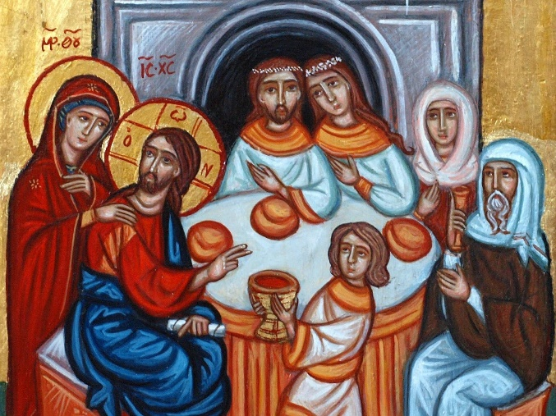
On the third day there was a wedding in Cana of Galilee, and the mother of Jesus was there. Jesus and his disciples had also been invited. When the wine gave out, the mother of Jesus said to him, “They have no wine.” Jesus replied, “Woman, what concern is that to us? My hour has not yet come.” His mother said to the servants, “Do whatever he tells you.”
John 2: 1-5
This week’s meditation was written by Mary Luti, a pastor and seminary instructor as well as an author. I came across this piece and it made me stop and think about this scripture passage in a way I hadn’t considered.
This is a familiar story about Jesus as he began his ministry with the miracle of turning water into wine.
Luti turns this story around to focus on Mary, Jesus’s mother and her role in telling Jesus to get on with his call from God.
Mary Luti writes: They have no wine. That’s all Mary says after noticing the lack. Could she be more indirect? Jesus knows what she wants him to do, but he’s reluctant to start doing things that have consequences. The wine she wants him to make will be free to the guests, but it could cost him plenty. He demurs.
Mary ignores him and marches over to the serving table as if he’d said no problem instead of no way. After all, Mary said a risky yes to an angel several years before and so she’s not about to take no for an answer from Jesus.
It’s human history she’s talking about, life’s disappointed guests milling around with empty glasses from time immemorial. Mary is done waiting. It’s time for the mighty to fall, the poor to get justice, the best wine to flow. So, Mary wonders, why is he still nailing cabinets in Nazareth?
Jesus gives in, makes liquid heaven and gives it to us, the undeserving, who can’t tell the difference between rotgut and Rothschild.
Mary Luti observes: It’s a new party now. He’s out of the house, loosed on the world. Thanks be to God for mothers who tell us to get up and get going, especially Jesus’s mother.
Let us pray that when we think we’re not ready to get up and get going to do God’s work, someone like Jesus’ s mother Mary will come along and nudge us forward.
Blessings and Peace,
Pastor Diane

