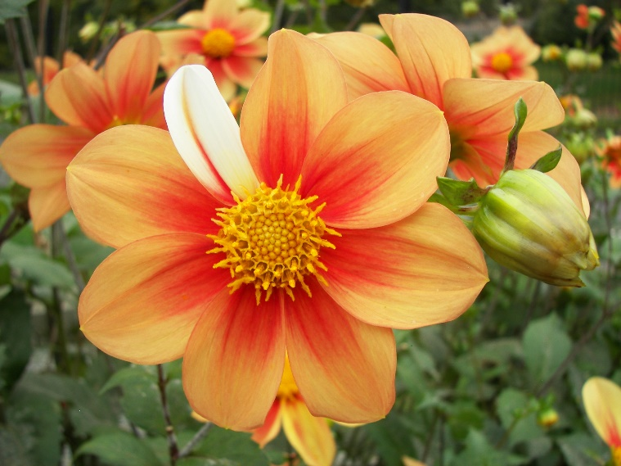
A Hymn to Imperfection
Hey! Let’s celebrate weakness!
Yes! You know!
Weakness as in failure!
Let’s celebrate the slips and slops, the drops and fall and oh-oh that teach us wisdom and compassion and patience and humor and understanding of what it means to be not a human being, but a human becoming.
Let’s celebrate all those opportunities for growth that were ours yesterday and today.
Let’s celebrate for ourselves. Let’s celebrate for each other.
And, while we’re at it, let us give thanks for the mistakes we will make tomorrow.
If we find them painful or a bit embarrassing we can remember that perfection means having no room for improvement, no need for anyone else.
And who wants that? Let us be grateful, that God is still shaping us!
Written by Joy Cowley
So, the other day while I was searching among the documents I have saved on my computer, this appeared, almost out of nowhere. And, I read it again, for the first time, or so it seemed.
I have to admit that I like to think that perfection is perfect. I don’t think I’m the only one who wants to do, to say, to have everything perfect in my life. And, I know that perfection just isn’t going to happen, at least not in my lifetime.
I’m pleased that Joy has reminded me to take a deep breath from time to time and relax a bit, knowing that only God is perfect and that achieving what I consider to be perfection, just isn’t truly perfection.
So, when life comes at you and you’re feeling that somehow you’ve missed the mark, take it easy on yourself. It’s OK to mess up. After all, God is still shaping us. Have a wonderful time enjoying your imperfection. It’s perfect just as it is.
Blessings and Peace,
Pastor Diane

