October 11, 2026
Twentieth Sunday after Pentecost
“All that we are, all that we have,
and all that we will become is a gift from God.”
*Indicates all who can, please stand

Gathering Music: “Traumerel” Schumann

* Call to Worship
Gather at the mountain of God’s holiness.
Today is a day to celebrate God.
Gather aware of those you left behind to be here.
Today is a day to stand in the gap between God and God’s children.
Gather to share God’s presence.
Today is a day of transformation for us and for God’s world.

*Opening Hymn: “We Sing Your Mighty Power, O God” No. 64

* Opening Prayer
From the many experiences throughout the week, we come together as a community to express what you mean to our lives, O God. Whatever we bring, make it yours. Whatever we experience in this time of worship; let it be in your presence. Whatever we take with us; let it be your holy and gentle Spirit. Amen.

* Prayer of Confession
Remember us, O God when you show favor to your people. Deliver us from our sins for we and our ancestors have sinned against you. We have committed injustices. We have failed to consider your wonderful works. We have forgotten abundance and steadfast love. We have put you to the test. Forgive us God. Amen.

*Words of Assurance

*Gloria Patri

The Choir: “My Lord”

Scripture readings: Exodus 32: 1-14 Philippians 4: 1-9
Matthew 22: 1-14

Message: “I’ve Changed My Mind”

Hymn: “Be Thou My Vision” No. 595

Sharing our Joys and Concerns
Pastoral Prayer
Lord’s Prayer

Presenting our Gifts

*The Doxology

*The Dedication Prayer
Loving God, we know you don’t seek offerings of gold or finest clothes. We don’t want to be distracted by what we have or what we wear, or any other symbols of success and importance. We offer these gifts and our whole selves in joy and trust. We bring what we have and who we are so that we may be a sign of hope and peace for a world in need. Amen.

*Closing Hymn: “I’ve Got Peace Like a River” No. 530

* Benediction
Go into the world that cries out for compassion.
Let us be like trees that bear the fruit of love.
Be like fountains that spring forth for peace.
Let us be like mighty rivers that flow for God’s justice.
Be like eagles that soar high on the wings of hope.
May others thank God because of us.
God bless, God bless, God bless.

Postlude: “Recessional” Battman

Choir practice will be held this Wednesday evening at 7:00

We will begin a new Bible Study on Wednesday, October 21 at 5:30pm. Our study guide is Light of the World. Come and join us as we begin an early exploration of the season of Advent.

Just a reminder: Please silence or turn off your cell phones during worship.
Pastor Diane Thomas
Pastor Phone: (928) 642-6676
Church Phone: (419) 683-2745
Pastor email: dsthomas18@ymail.com
Church email: crestlinecalvary@gmail.com
The church website: www.crestlinecalvary.com
You may view our worship service on YouTube. Our channel is YouTube@calvaryucc8132.

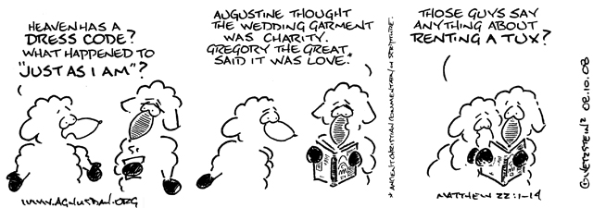

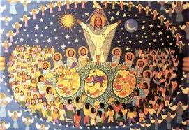

Welcome to Calvary
United Church of Christ
October 11, 2026
Twentieth Sunday after Pentecost
“Serving God and Crestline Since 1859”
We welcome you and thank you for joining in worship!

