October 18, 2026
Twenty-first Sunday after Pentecost
“All that we are, all that we have,
and all that we will become is a gift from God.”
*Indicates all who can, please stand

Gathering Music: “Trust In His Steadfast Love” Moore

* Call to Worship
Here we are God, with our bits of faith and our pieces of hope.
Here we are God, in our giving and taking moods.
God, will you be here with us as we talk, dream, listen, sing and pray?
God, will you come and join us? Will you hold and comfort, push and poke us, speak to us, feed us?
Here we are God. Let us worship together.

* Opening Hymn: “All Creatures of Our God and King” No. 22

* Prayer of Invocation
Holy and loving God, you have spoken to us through the pillar of cloud, silent whispers in the middle of the night, prophetic voices of visionaries. May our hearts and minds be uncluttered so that we may be open to the movement of your Spirit. Help us find courage and strength to abide by your word, your spirit and what you expect from us. Amen.

* Prayer of Confession
Remember us, O God, when you show your favor to your people; deliver us from our sins, for we like our ancestors, have turned away from you, we have committed injustices. We have failed to consider your wonderful works. We have forgotten your abundance and steadfast love. Forgive us we pray. Amen.

*Words of Assurance

*Gloria Patri

The Choir: “How Quiet Is the Night”

Scripture Readings: Exodus 33: 12-23 1 Thessalonians 1: 1-10
Matthew 22: 15-22

Message: “Believing is Seeing”

Dedication Hymn: “What a Friend We Have in Jesus” No. 585

Sharing our Joys and Concerns
Pastoral Prayer
Lord’s Prayer

Presenting our Gifts

*The Doxology

* The Dedication Prayer
Though the faces on our offerings show the images of ourselves, O God, we offer them with the heart of love, the joy of gratitude and the humbleness of our loving faith. Bless our gifts that they may be a blessing to others. May they bring transformation of the heart, liberation of the oppressed, dignity to the marginalized and hope in the world. Amen.

*Closing Hymn “O Master, Let Me Walk with Thee” No. 602

* Benediction
Go boldly into the world. Go seek out new ways to be God’s holy ones. Be imitators of the one who showed what it means to live. Go into the world with God’s good news.
We are the message.
Be the message. Do the message
We will live the message.
Go now in peace.
Thanks be to God. Amen.

Postlude: “Fatasia on “Austrian Hymn” Paxton

Consistory will meet this morning following worship

Choir practice will be held this Wednesday evening at 7:00

We will begin a new Bible Study this Wednesday, October 21 at 5:30pm. Our study guide is Light of the World. Come and join us as we begin an early exploration of the season of Advent.

Attendance for Oct.11th was 17 adults.

Just a reminder: Please silence or turn off your cell phones during worship.
Pastor Diane Thomas
Pastor Phone: (928) 642-6676
Church Phone: (419) 683-2745
Pastor email: dsthomas18@ymail.com
Church email: crestlinecalvary@gmail.com
The church website: www.crestlinecalvary.com
You may view our worship service on YouTube. Our channel is YouTube@calvaryucc8132.

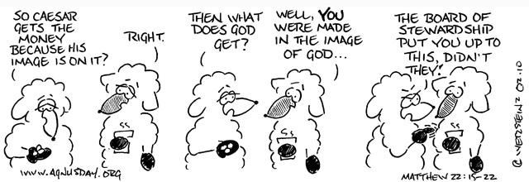

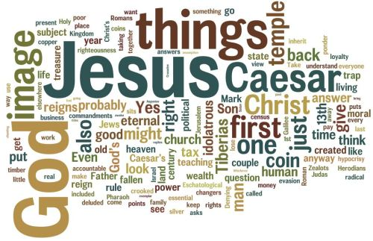
Welcome to Calvary
United Church of Christ
October 18, 2026
Twenty-first Sunday after Pentecost
“Serving God and Crestline Since 1859”
We welcome you and thank you for joining in worship!

