October 25, 2026
Twenty-second Sunday after Pentecost
“All that we are, all that we have,
and all that we will become is a gift from God.”
*Indicates all who can, please stand

Gathering Music: “Blessed Assurance” Knapp

* Call to Worship
O God, you have been our dwelling place in all generations.
From forever in the past to forever in the future, you are God.
A thousand years in your sight are like yesterday when it is past.
From forever in the past to forever in the future, you are God.
You satisfy us in the morning with your steadfast love.
From forever in the past to forever in the future, you are God.
We praise you and your glorious power.
From forever in the past to forever in the future, you are God and we worship you.

*Opening Hymn: “Joyful, Joyful, We Adore Thee” No. 2

* Opening Prayer
Through joy-filled and sorrowful stories, you shape a people to live and to love. O God, when we least expect it and when we have known well in advance, you open us to new possibilities. We praise you and seek your wise guiding. We honor you our worship this morning. Amen.

* Prayer of Confession
Forgive us, God when we doubt our abilities. Forgive us, God when we question the power of you working through us. Forgive us, God when we fail to love ourselves as you love us. Forgive us, God when we fail to love each other. Forgive us, God we pray. Amen.

*Words of Assurance

*Gloria Patri

The Choir: “It Is Well With My Soul”

Scripture Readings: Leviticus 19: 1-2, 15-18 Deuteronomy 34: 1-2
Matthew 22: 34-46

Message: “Endings and Beginnings”

Hymn: “Open My Eyes, That I May See” No. 586

Sharing our Joys and Concerns
Pastoral Prayer
Lord’s Prayer

Presenting our Gifts

*The Doxology

*The Dedication Prayer
With what you see before us, God, we demonstrate our deepest love. Receive our gifts—our very best—as sweet offerings before you. May they be the blessing to others that they have been for us. Amen.

*Closing Hymn: “Help Us Accept Each Other” No. 487

* Benediction
We are God’s people. We are all on the journey of life. We choose to seek God’s guiding wisdom in our endings and our beginnings.
We are willing to let go, to be free to travel the way that unfolds before us as we learn to love each other, our neighbors, strangers and God with our whole heart, mind, strength—our whole self. Amen.

Postlude: “Rise Up and Serve the Lord” Harris

Choir practice will be held this Wednesday evening at 7:00

Bible Study continues this Wednesday at 5:30pm. Our study guide is Light of the World. Come and join us as we begin an early exploration of the season of Advent.

Next Sunday during worship we will celebrate a time of remembrance for those in our congregation and loved ones who have passed away.

Attendance for Oct.18th was 20 adults.

Just a reminder: Please silence or turn off your cell phones during worship.
Pastor Diane Thomas
Pastor Phone: (928) 642-6676
Church Phone: (419) 683-2745
Pastor email: dsthomas18@ymail.com
Church email: crestlinecalvary@gmail.com
The church website: www.crestlinecalvary.com
You may view our worship service on YouTube. Our channel is YouTube@calvaryucc8132.
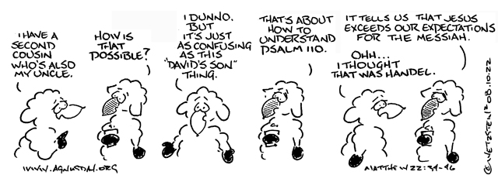

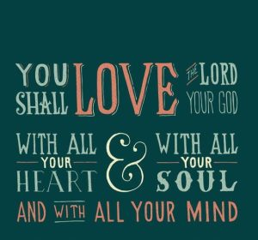
Welcome to Calvary
United Church of Christ
October 25, 2026
Twenty-second Sunday after Pentecost
“Serving God and Crestline Since 1859”
We welcome you and thank you for joining in worship!

