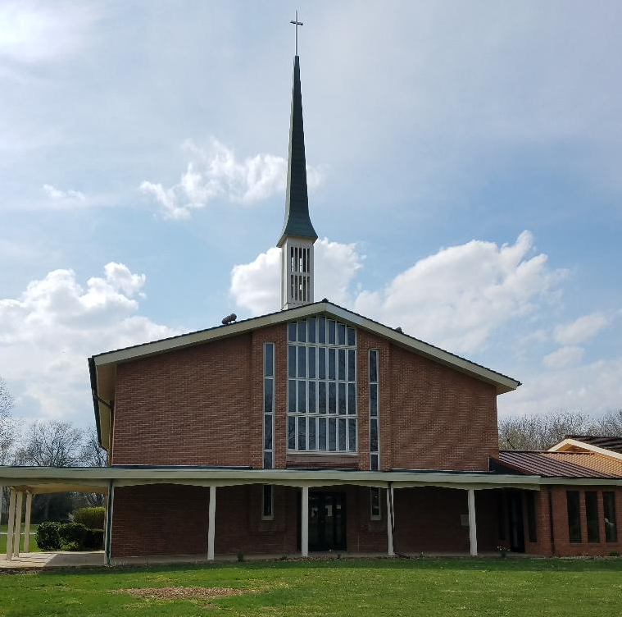

Not long ago, something popped into my email inbox that caught my attention. It was an article written by Allen T. Stanton from the University of Tennessee Southern University.
The article Mr. Stanton had written came to me from Ministry Matters.
The piece began: Our churches need to be younger. It is an engrained truth, repeated so much that one halfway expects these words to be found somewhere in a footnote in a letter from Paul. Speaking of Paul, let’s remember that the congregations Paul addressed were small in numbers yet they managed to thrive in spite of all their obstacles.
Anyway, over the years, the adage has become a tirelessly repeated indicator of church vitality and church health. Want to grow? Attract young people.
These are indeed familiar words. I’ve heard them over and over again in the congregations I’ve served. Yet, as Mr. Stanton points out, this truth is rooted in the suburban and metropolitan areas of our country. But, Mr. Stanton writes, for many rural communities this truth is just plain old bad advice.
Mr. Stanton writes the reality is that the fastest growing demographic in smaller communities is retirees. And, it’s true our country’s population is aging.
As I read all this I began to think and reflect on our congregation here in Crestline. Many folks may be lamenting our loss of membership for whatever reasons. Some may be looking back to the “good old days.”
But I wonder, why not celebrate who we are as a congregation, right here, right now?
Indeed, we are facing challenges, we are an older congregation, but that doesn’t mean we aren’t alive and a vital part of our community.
We have had the foresight to provide our building as a place for Crestline Child Care to live and grow.
We are actively involved in C.A.M.P. Many of our members contribute their time and talents to our community in a number of different ways.
So, let’s rejoice and enjoy who we are as a congregation who welcomes all people to join us, no matter what age.
Blessings and Peace,
Pastor Diane

