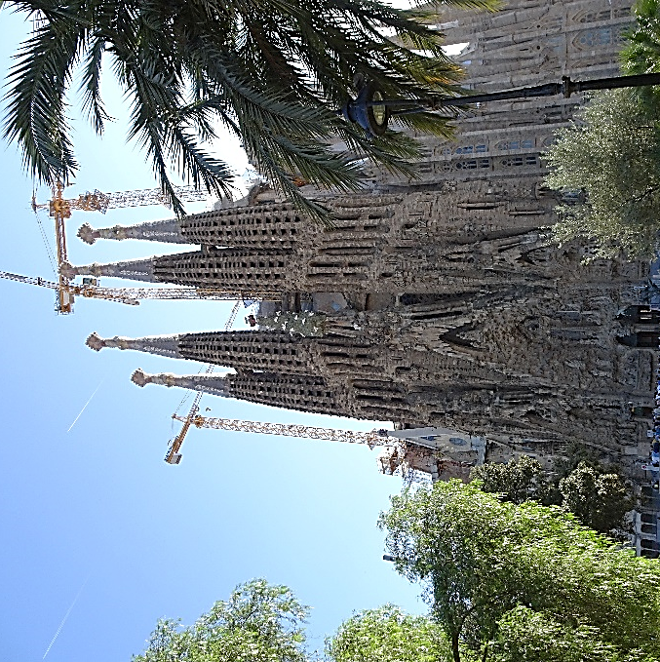
One thing I asked the Lord that will I seek after: to live in the house of the Lord all the days of my life, to behold the beauty of the Lord and to inquire in God’s temple. For God will hide me in his shelter in the day of trouble: he will conceal me under the cover of a tent; God will set me high on a rock. Psalm 27:4-5
Rev. Jennifer Garrison is a writer and pastor who lives in the Pacific Northwest. She has written a reflection about the church and congregations.
Rev. Garrison observes that one temptation is to believe that we will find God only if we build the perfect structure.
Over the past several years, I have visited Barcelona, Spain a few times. This is a picture of the Cathedral known as Sagrada Familia (sacred family). The church was designed by the architect, Antoni Gaudi. Construction on the church began in 1882 and was finally completed just a few months ago.
The cathedral is a magnificent structure. Its exterior is filled with carvings depicting events in the life of Christ. The building is huge. It towers over the city.
I thought about Sagrada Familia as I read Rev. Garrison’s reflection about church buildings. She points out that God doesn’t fit into the boxes we make for God. She notes that the psalmist realizes that God doesn’t try to make God fit in only one place. The psalmist is wise enough to know that one is able to find God in a house or a temple or even a tent.
And so, Rev. Garrison asks: “Where do you seek the Holy? In the comfort and community of home, gathered around a table?
Or do you look for God under the soaring rooftops of the temple—a place of worship? Perhaps you find the Divine in the temporary structure of the tent—on the go.
Rev. Garrison goes on to write that all too often we are tempted to believe that the cloth must be laid just so, the candles lit correctly, your heart swept clean, your mind a tidy dwelling place.
Indeed, all too often I think we are tempted to think that God exists only in our church buildings, whether they be grand and glorious or small and compact. Yet we all know that God is found wherever we are.
Our churches are structures. Our congregations are people who gather to worship wherever and whenever we are together.
Our church building is indeed a sacred space, but it is after all a place where we worship. The building provides space for our gatherings and community child-care. It’s a space we gladly share. God is here at Calvary U.C.C. But God is also with us when we aren’t in the building. Remember, God is ready to live with you wherever you are.
Blessings and Peace,
Pastor Diane

