November 8, 2026
Twenty-fourth Sunday after Pentecost
“All that we are, all that we have,
and all that we will become is a gift from God.”
*Indicates all who can, please stand

Gathering Music: “Abide With Me” Monk

* Call to Worship
We have gathered here this morning to worship God.
We have come seeking comfort, inspiration, community and insight.
We have come to open ourselves to the power of God’s presence in our midst.
We have come to offer up the seasons and the turnings in our lives and to ask God’s help in our learning and in our growing.

* Opening Hymn: “All People That on Earth Do Dwell” No. 18

* Opening Prayer
Loving and gracious God in this time of worship help us discover signs of your presence. Strengthen our hearts that we may not be distracted or overcome with doubt or despair. Awaken us to your holy presence as we hear your good news, sing your praise and offer you our prayers. Amen.

* Prayer of Confession
Merciful God, you are our strength and our delight; you give us all we need to live. Yet we are distracted by all that glitters, always grasping for more. All too often we trust in our own happiness, rather than trusting in your goodness. Forgive us we pray, help us to turn back to you, our source of life. Amen.

*Words of Assurance

*Gloria Patri

The Choir: “Lord Be Glorified”

Scripture Readings: 1Thessalonians 4: 13-18 Matthew 25: 1-13

Message: “Be Prepared”

Hymn: “Dear Lord and Father of Mankind” No. 594

Sharing our Joys and Concerns
Pastoral Prayer
Lord’s Prayer

Presenting our Gifts

*The Doxology

* The Dedication Prayer
Loving God, your still small voice has called to our worshipping community, challenging us to make the sacred journey. May our gifts of money, time and talent bring hope in a world where people are hungry, oppressed and ignored. Bless our offerings that they may become blessings to others and praise your name. Amen.

*Closing Hymn “Savior, Like a Shepherd Lead Us” No. 558

* Benediction
Go in the strength of God’s spirit,
lighting lamps of justice with the oil of righteousness.
May the grace of God nourish you,
and the love of God sustain us.
Go in peace, counting on Christ, the love of God and the sweet communion of the Holy Spirit. Amen.

Postlude: “Our Great Savior” Prichard

Choir practice will be held this Wednesday evening at 7:00

Bible Study continues this Wednesday at 5:30pm. Our study guide is Light of the World. Come and join us as we begin an early exploration of the season of Advent.

Consistory will meet next Sunday, November 15 following worship.

Attendance for Nov.1st was 23 adults and 2 children.

Just a reminder: Please silence or turn off your cell phones during worship.
Pastor Diane Thomas
Pastor Phone: (928) 642-6676
Church Phone: (419) 683-2745
Pastor email: dsthomas18@ymail.com
Church email: crestlinecalvary@gmail.com
The church website: www.crestlinecalvary.com
You may view our worship service on YouTube. Our channel is YouTube@calvaryucc8132.



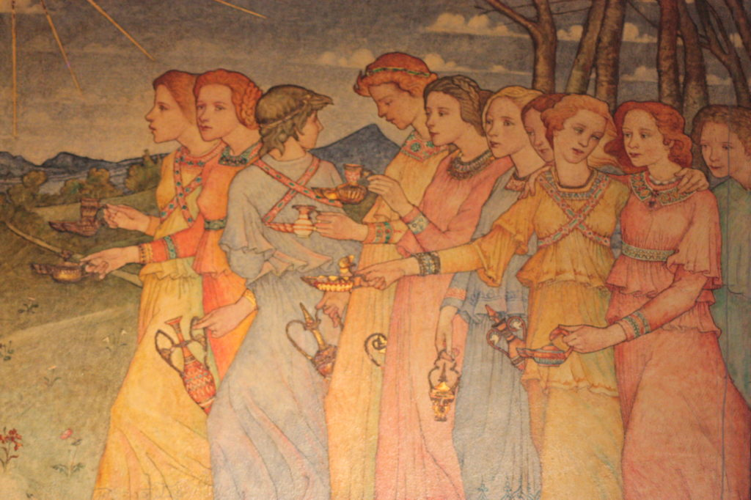
Welcome to Calvary
United Church of Christ
November 8, 2026
Twenty-fourth Sunday after Pentecost
“Serving God and Crestline Since 1859”
We welcome you and thank you for joining in worship!

